8.101: a) If the objects stick together, their relative speed is zero and 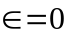. b) From Eq. (8.27), the relative speeds are the same, and 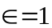. c) Neglecting air resistance, the speeds before and after the collision are 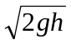 and 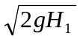, and 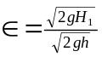 = 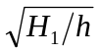. d) From part (c), 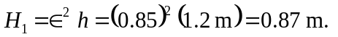e) 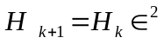, and by induction 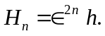 f) 